# CS 255 System Design Document Template

## UML Diagrams

### UML Use Case Diagram

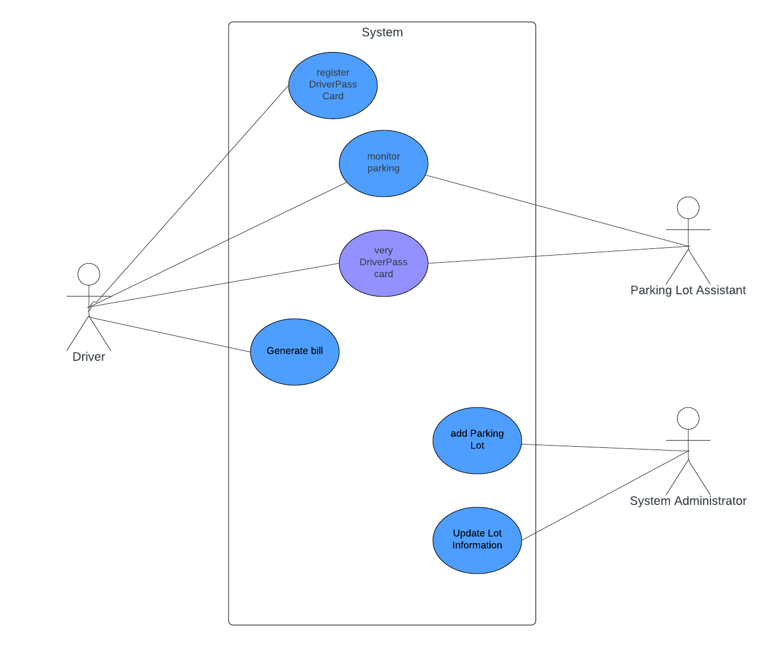

### UML Activity Diagrams

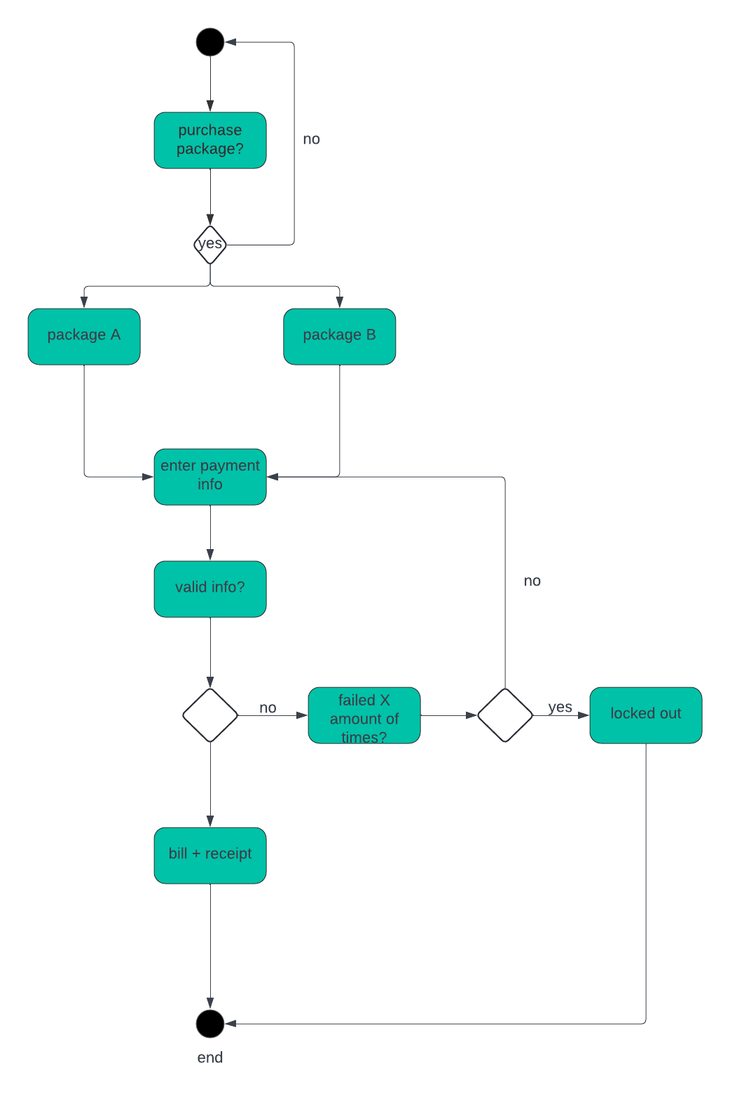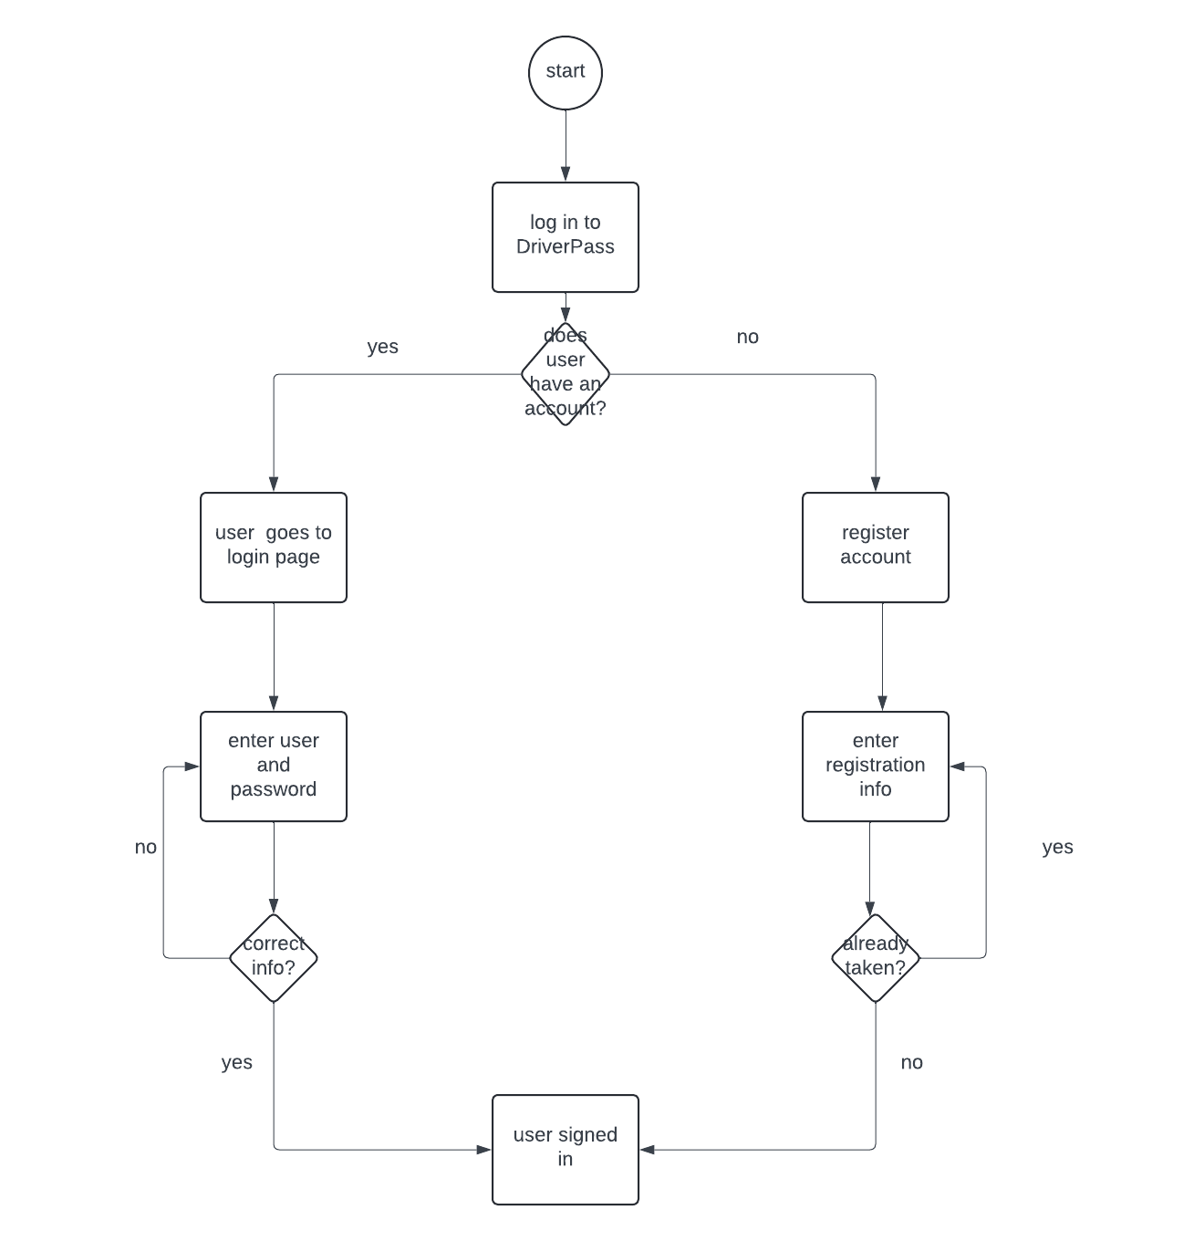

### UML Sequence Diagram

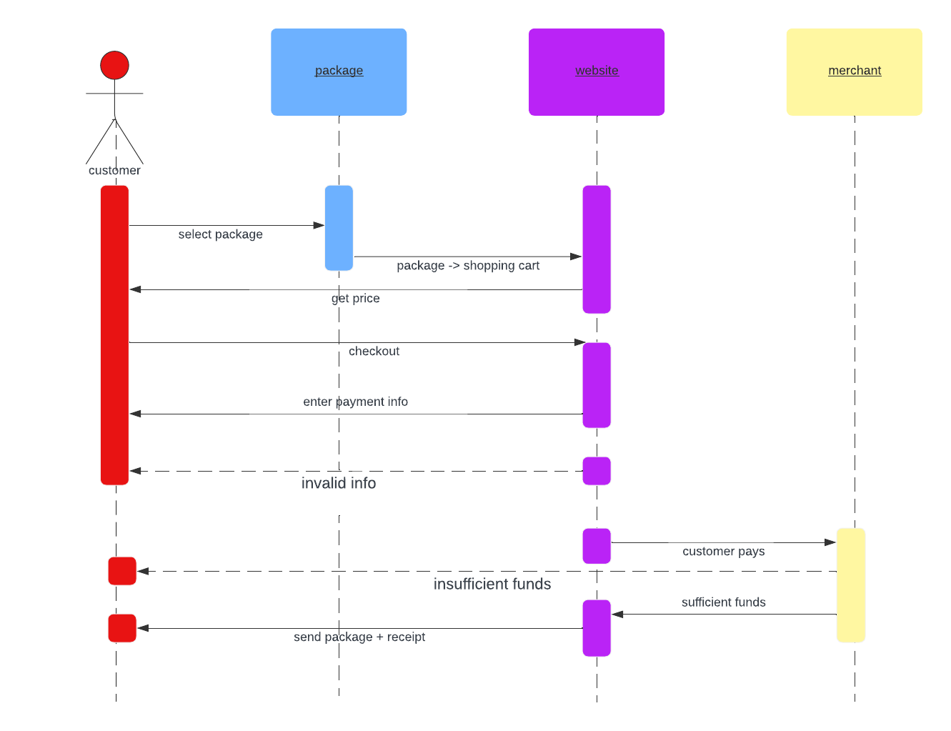

### UML Class Diagram

## Technical Requirements

There are several things needed in order to run the Driver Pass program, which are listed below.

* Software
  + Server, Windows is recommended.
  + Database, SQL is popular and easy to use.
  + Web server
  + Malware prevention services
  + Backup for all data
* Hardware
  + Stable internet connection
  + Dedicated storage for user data/database
  + System to access website (mobile device/computer)
  + Dedicated server

